

Later this half term we will be learning about Autumn and the natural changes that occur during the season. We will explore and collect leaves, conkers, pine cones, and acorns. If you find anything interesting for our collection, feel free to bring it into Nursery.

Welcome to Nursery! During this half term we will be getting to know each other, making new friends and learning the Nursery routine. We hope the children settle quickly and enjoy their time with us.

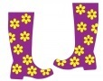**[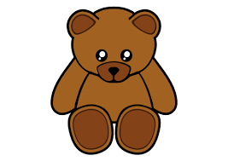](http://www.google.co.uk/imgres?imgurl=http://www.clipartbest.com/cliparts/ncB/G7r/ncBG7rERi.png&imgrefurl=http://imgbuddy.com/teddy-bear-clip-art.asp&h=392&w=555&tbnid=D1Yc4UTx7Ye7wM:&zoom=1&docid=x419rQcO0wJvLM&ei=A_LpVJHSA8zuaNuZguAK&tbm=isch&ved=0CJABEDMoUjBS)**

If your child is staying for lunch, could you please tick the class list on the lunchbox shelf when you bring your child into Nursery.

We will be learning to say and sing Nursery Rhymes and Songs such as:

Jack and Jill

Humpty Dumpty

Baa Baa Black Sheep

Incy Wincy Spider

Hickory Dickory Dock…

and others!

In Nursery this half term, we will be learning about:

Don’t forget to look on the school website as we will be posting photos of the children taking part in activities this half term. www.st-peters-hednesford.staffs.sch.uk

**Please make sure all of your child’s belongings are named.**

Please try to teach your child to put on their own coat.

As the weather gets colder, the children will need a warm coat to wear at Nursery. We will be playing in our outdoor area whatever the weather.

Please can you provide your child with a pair of wellies to keep in school for rainy days and muddy play. These need to be clearly named.

We have two teddies in Nursery called Hamish and Dougall. They like to go home with the children and stay for the weekend. Please let us know if you would like your child to look after one of them or are planning a holiday or weekend away and would like to take a bear with you!

**Nursery Rhymes**

**and Autumn**