Topic  Create your own Aztec headdress ready for an end of term Aztec fashion show.  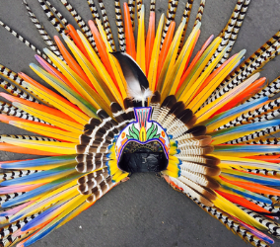  (3 points) | Maths  Create a timetable of a day over a weekend. Write the times in 12 hour and 24 hour digital.  (3 points) | English  Create a setting for a story based in the Aztec era. For example, you could use an Aztec temple. Try to include a range of fronted adverbials.  (5 points)
IT  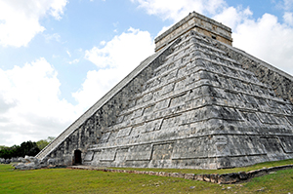  Next half term our topic is the Aztecs. Research the Aztecs, where they lived and what life what like for an Aztec. Show your findings on a PowerPoint and bring the printed slides in.  (5 points) | Take 15 Homework  Year 4 Autumn 2  Complete activities to collect 15 points  Tasks to be returned by Friday 14th December  Please put your name on all of your completed tasks. | Topic  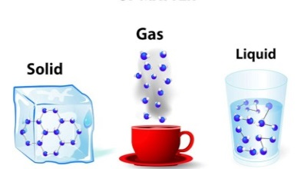  This half term, our science topic will be solids, liquids and gases. Create a glossary of terms for this topic. Be creative in how you present it!  (3 points)
English  This half term, we will be focusing on simple, compound and complex sentences. Create a poster explaining each sentence type and give examples of each. Be creative with how you present it!  (4 points) | Topic  The Aztecs invented chocolate. Find a recipe and make your own Aztec style hot chocolate. Take pictures and write a set of instructions on how you made it. Then, sit back, relax and enjoy your hot chocolate!  (4 points) | Maths  Create 5 of your own multiplication and division word problems and solve them. Challenge yourself by writing 2 step word problems!  (4 points)

